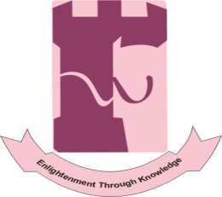
SHAHEED BENAZIR bHUTTO Women UNIVERSITY PESHAWAR
(FORMERLY NAMED AS FRONTIER WOMEN UNIVERSITY PESHAWAR)
ACAACADEMICS SECTION
ADMISSION SECTION
Landay Sarak, Near Charsadda Road, Peshawar
Phone. No: 091-9224726
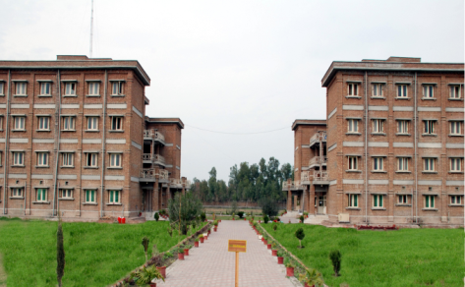
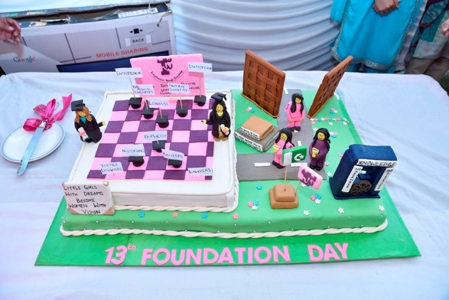
The first female university of the province, established in accordance with the Frontier Women University Act 2004, passed by the Provincial Assembly and assented by the Governor Khyber Pakhtunkhwa on 7th February, 2005. However, according to Amendment Bill (Khyber Pakhtunkhwa Act No. XI 2010), passed by the Provincial Assembly Khyber Pakhtunkhwa on September 6, 2010, the University was renamed as Shaheed Benazir Bhutto Women University (SBBWU).The University is destined to be a leading public sector Women University to impart education to the female population of this region in order to develop scientific, socio cultural, economic and political stability, through learner centered teaching and research, while strengthening the identity of the students at national and international level.
The primary objective of Shaheed Benazir Bhutto Women University Peshawar is to accomplish the assigned mission of providing quality education to the female students in accordance with the latest syllabi and modern trends so that it can emerge as the leading public sector female university of the country.

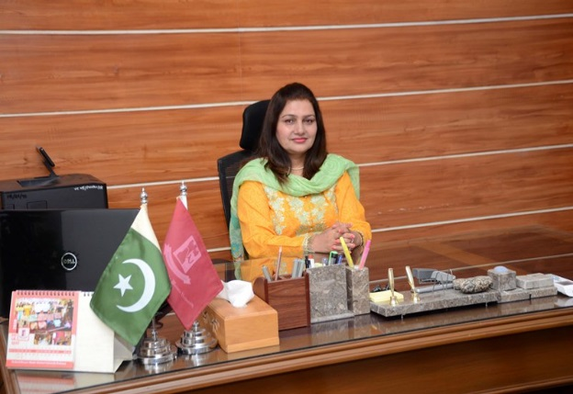
Message from the Vice Chancellor
Shaheed Benazir Bhutto Women University Peshawar is a premier women university of Khyber Pakhtunkhwa. It has earned this position by virtue of its futuristic outlook towards higher education, strong emphasis on research and focus on innovation and entrepreneurship. Its academic programmes are designed to meet the national needs and challenges of the new millennium. Traditional fields of Social, Biological and Physical Sciences have been updated with emerging trends and new disciplines are being introduced to prepare professionals to manage the ever-growing demands of knowledge economy with requisite degree of expertise. Shaheed Benazir Bhutto Women University Peshawar has come a long way to develop into a global centre of excellence for imparting higher education. The universities at large have assumed the role of drivers of knowledge inventers and discoveries. Shaheed Benazir Bhutto Women University Peshawar, being a premier educational institution in Khyber Pakhtunkhwa has been keenly building a consortium across the government, business and higher education sectors to actively pursue sustainable growth of a knowledge-based economy. In conjunction with offering programmes of studies in diversified disciplines. One of the top priorities of Shaheed Benazir Bhutto Women University Peshawar is to give its academic pursuits a tinge of diversity. The first ever female university was established in accordance with Frontier Women University Act 2004, passed by the Provincial Assembly and assented by the Governor Khyber Pakhtunkhwa on 7th February, 2005. However, according to the revised Act Amendment Bill (Khyber Pakhtunkhwa Act No. XI 2010), passed by the Provincial Assembly of Khyber Pakhtunkhwa on September 6, 2010, the University was renamed as Shaheed Benazir Bhutto Women University (SBBWU).
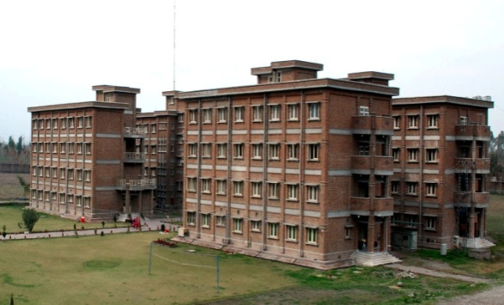
The University is destined to be a leading public sector Women University to impart education to the female population of this region in order to develop scientific, socio cultural, economic and political stability, by providing quality teaching and research, while strengthening the identity of the students at national and international level. Over a period of few years since its inception, Shaheed Benazir Bhutto Women University Peshawar today continues its forward march, never looking back, committed to excellence in teaching and research. In contemporary times, the transformation in the world economy is perennial; technologies evolve at fast track. These are extra ordinary times requiring extraordinary preparations and efforts. Students and parents alike acknowledge the changing trends and are eagerly seeking out institutions of higher learning where their thirst, curiosity and drive for knowledge are adequately quenched; where all round personality development takes place holistically, abreast with knowledge and managerial skills and the drive to lead and succeed; where they can take charge of their destinies with an open mind and determination.
We also hope to develop new approaches to achieving excellence in education. With an aim to nurture creative, open-minded and compassionate women leaders for the next generation, we will continue to actively support and stimulate our students as they take on new challenges. Shaheed Benazir Bhutto Women University serves as a learning ground where anything except despair, is acceptable, same is reflected in the saying of the founder of Pakistan;
"I have always maintained that no nation can ever be worthy of its existence that cannot take its women along with the men. No struggle can ever succeed without women participating side by side with men. There are two powers in the world; one is the sword and the other is the pen. There is a great competition and rivalry between the two. There is a third power stronger than both, that of the women."
(Muhammad Ali Jinnah, Islamia College Peshawar)
With best wishes,

Prof. Dr. Razia Sultana
Vice Chancellor
Shaheed Benazir Bhutto Women University, Peshawar

The List of Departments and the Programs they Offers:
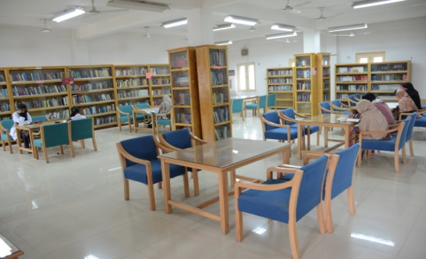
- Department of Chemistry ( M.Sc 2-year, BS 4-year)
- Department of Zoology (M.Sc 2-years, BS 4-year)
- Department of Microbiology (BS 4-year)
- Department of Biochemistry ( BS 4-year)
- Department of Bioinformatics ( BS 4-year)
- Department of Physics (a. BS 4-year, b. Msc 2-years)
- Department of Mathematics ( M.Sc 2-year, BS 4-year, M.Phil, Ph.D)
- Department of Statistics ( M.Sc 2-year, BS 4-years, M.Phil)
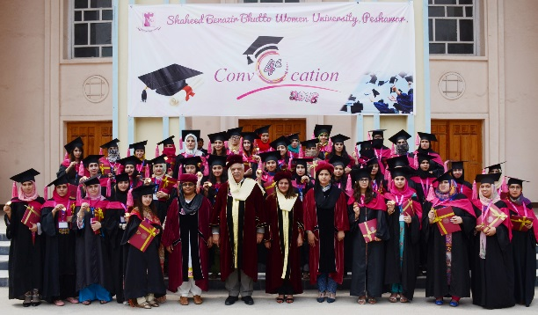
- Department of Computer Science ( M.Sc 2-year, BS 4-year, M.Phil)
- Department of Management Sciences (a. MBA 3.5 Years, b. MBA 2.5-years, c. BS 4-years)
- Department of Economics ( M.Sc 2-year, BS 4-year, M.Phil)
- Department of Psychology (MSc 2-year. BS 4-year, M.Phil, Ph.D, PGDCP)
- Department of Law (a. BS 5-years, b. Human Right Course, c. Family Law Course)
- Department of Political Science (a. BS 4-year, b. MA 2-years, c. MPhil)
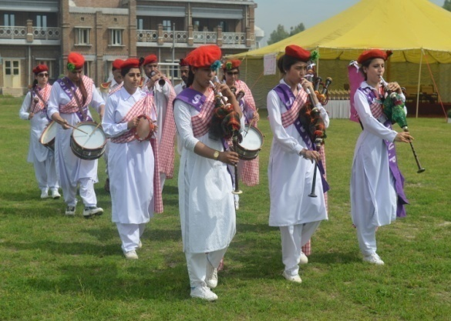
- Department of History ( a. BS 4-year , b. M.A 2-years)
- Department of Urdu (a. BS 4 Year, b. M.A 2-year)
- Department of English (a. BS 4-years, b. M.A 2-year, c. M.Phil, d. Certificate Course)
- Department of Islamiyat (a. BS 4-years, b. M.A 2-year, c. M.Phil, d. Ph.D)
- Department of Archeology (BS 4- Year)
- Department of Art & Design ( BS 4-year)
- Department of Education. (a. BS 4-years, b. M.A 2-year)
- Women Development Centre ( Certificate Course)
- Department of Health &Physical Education (BS 4- year)

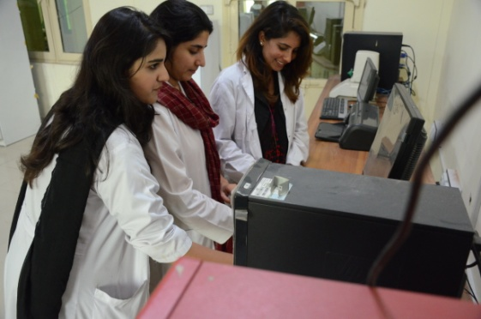
Scholarships and Financial Assistance
SBBWUP has funded a significant number of students who face financial constraints, and are unable to continue their studies. There are different scholarships available for students to choose
- Scholarship for top 20 female students of all Boards and Universities of Khyber Pakhtunkhwa.
- Merit Scholarship for position holders.
- HEC Need based scholarship for needy students.
- Prime Minister tuition fee reimbursement scheme program for less developed areas.
- Mora Education Scholarship.
- Scholarships for Minority Students
- Scholarship under HEC-French need based scholarship Program.
- Pakistan Scottish Scholarship Scheme.
- Frontier Education Foundation Scholarship
- PAK-USAID merit and need based scholarship program
Applications are invited for award of USAID funded merit and need based scholarship for BS Economics, BS Psychology and BS English. The scholarship will be provided on merit-cum-need basis to those students who are financially disadvantaged and cannot pay their dues. The selection of the students for the award of scholarship will be made by Institutional Scholarship Award Committee (ISAC) and that shall be final. The Application form can be downloaded from University website www.sbbwu.edu.pk or can be obtained from Admission Section, Shaheed Benazir Bhutto Women University, Peshawar.
Legacy and Location
The building of Shaheed Benazir Bhutto Women University, as it appears elegantly with a glamorous look, is the hub of academic, research, co-curricular and extracurricular activities of the province.

The SBBWUP provides University-scale services and facilities, including two libraries with thirteen thousand eight Hundred and eighty-one books, health and counseling centers, catering block, athletic facilities, and an array of extra-curricular activities.
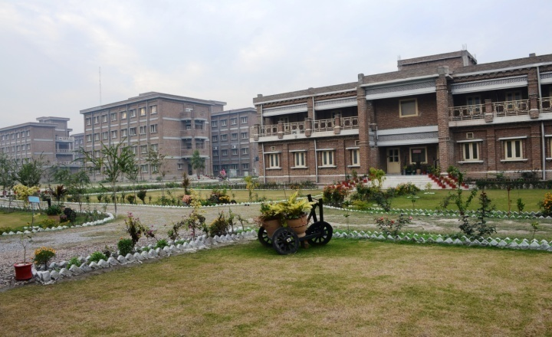
The Facilities include:

- Modern and well equipped laboratories
- International standard infrastructure
- Uninterrupted Power Supply
- Transport facility
- Conducive environment for women
- CCTV camera monitoring
- Hostel facility
- Mess of high standard with good food at nominal charges.
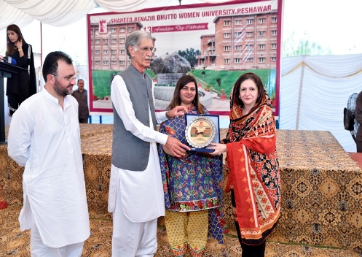
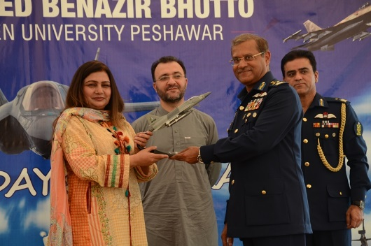
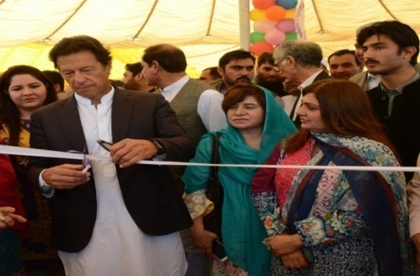
- Round the clock police security
ADMISSION NOTICE
FALL SEMESTER 2018-19

Applications for admission to the Undergraduate programmes are invited for which essential details are as under:

S.NO | PROGRAMME (4-Years) | ELIGIBILITY
1 | BBA | F. A / F. Sc / D. Com or equivalent, with at least 45% marks in aggregate  Entry Test: 50% Passing marks in entry test
2 | B.S(CS) | Intermediate with at least 45% marks in aggregate  Entry Test: 50% Passing marks in entry test
3 | BS (Art & Design) with specialization in  Fashion Design, Textile Design, Painting & Communication Design | Intermediate, with at least 45% marks in aggregate  Entry Test: Drawing Test
4 | BS Economics | Intermediate, with at least 45% marks in aggregate
5 | BS Psychology | Intermediate, with at least 45% marks in aggregate  Entry Test: 50% Passing marks in entry test
6 | BS Bio-Informatics | Intermediate (Pre-Medical /Pre- Engineering / ICS) or equivalent, with at least 50% marks in aggregate
7 | BS Microbiology | Intermediate (Pre-Medical) or equivalent, with at least 50% marks in aggregate  Entry Test: 50% Passing marks in entry test
8 | BS Bio-Chemistry | Intermediate with Chemistry, with at least 45% marks in aggregate
9 | BS Zoology | F.Sc. (Pre-Medical) with at least 45% marks in aggregate.  Entry Test: 50% Passing marks in entry test
10 | BS Chemistry | F.Sc. with at least 45% marks in aggregate.  Entry Test: 50% Passing marks in entry test
11 | BS Physics | Intermediate with Physics, with at least 45% marks in aggregate
12 | B.Ed (Hons) | Intermediate, with at least 45% marks in aggregate
13 | BS English | Intermediate, with at least 45% marks in aggregate.  Entry Test: 50% Passing marks in entry test
14 | BS Political Science | Intermediate, with at least 45% marks in aggregate
15 | BS Mathematics | Intermediate (Pre Medical) or intermediate with Mathematics or equivalent with at least 45% marks in aggregate
16 | BS Statistics | Intermediate with Mathematics or Statistics and having 45% marks in aggregate
17 | BS Islamiyat | Intermediate, with at least 45% marks in aggregate
18 | BS Urdu | Intermediate, with at least 45% marks in aggregate
19 | BS History | Intermediate, with at least 45% marks in aggregate
20 | BS Health and Physical Education | Intermediate, with at least 45% marks in aggregate
21 | BS Archeology | Intermediate, with at least 45% marks in aggregate
S.NO | PROGRAMME (2Years) | ELIGIBILITY
22 | ADE (Associate Degree in Education) | Intermediate, with at least 45% marks in aggregate
S.NO | PROGRAMME (5 Years) | ELIGIBILITY
23 | LLB | Intermediate, with at least 45% marks in aggregate and at least 50% marks in LAT.  (LAT Test as per HEC Schedule)

- In compliance to the directives of the Honorable Prime Minister of Pakistan, the entrance requirement for FATA students for the academic year has been increased to 40% (4 seats in each department per programme are reserved for FATA students).
- Two seats per discipline per programme are reserved for Afghan Students.
- Two seats per discipline per programme are reserved for Sports Students.
- Two seats in each department per programme are reserved for Disable Students

ADMISSION SCHEDULE FOR UNDERGRADUATE PROGRAMMES
DETAIL | DATE | VENUE
Issuance of Forms | Wednesday, 01st August, 2018 | Admission Section  Landay Sarak, Near Charsadda Road  Shaheed Benazir Bhutto Women University Peshawar
Closing Date for admission form submission & Entry Tests Registration. | Friday, 24th August, 2018
Trial for Sport Seats | Tuesday, 04th September, 2018
Display of Provisional Merit Lists | Wednesday, 05th September, 2018
Entry Tests | Thursday, 06th September 2018  - BBA  - BFA  - B.S.(CS)  - BS English  - BS Psychology  Sunday, 9th September 2018  - BS Zoology  - BS Chemistry  - BS Microbiology
Interview | Thursday, 06th September 2018  - Political Science  - Urdu  - Islamiyat  - Mathematics  - Statistics  - Economics  Tuesday, 11th September 2018  - Zoology  - Chemistry  - Microbiology  - Bio-Chemistry  - Bio-Informatics  Friday, 14th September 2018  - Physics  - LLB  - History  - Health & Physical Education  - Archeology  - B.Ed (Hons)
Display of Final Merit Lists | Wednesday, 12th September 2018  - BBA  - BFA  - BS (C.S)  - English  - Psychology  - Zoology  - Chemistry  - Microbiology
Fee Remittance | Friday, 14th September 2018 to Thursday, 20th September 2018
Display of Hostel List | Monday, 17th September 2018  - 1st Merit List  Tuesday, 18th September 2018  - 2nd Merit List
Commencement of Classes | Monday, 1st October 2018

DEPARTMENT OF ENGLISH LANGUAGE & LITERATURE
CERTIFICATE in English language (6 Months)
The certified course aims at enhancing competency in the following five skills;
1. Reading 2. Writing 3. Speaking 4. Listening 5. Grammar
ELIGIBILITY: Intermediate. (F. A / F. Sc)

WOMEN DEVELOPMENT CENTER
Certificate in Women Development (6 Months)
Course Content:
- Law 2. Fundamentals of Management 3. Nutrition 4. Interior Decoration
- Information Technology (IT) 6. Functional English 7. Personal Grooming
ELIGIBILITY: Matriculation
 | ADMISSION SCHEDULE for Certificate Courses
Issuance of Forms |  | Wednesday 01st August, 2018
Last Date for Submission of Admission Forms |  | Friday, 24th August, 2018
Interview of Shortlisted Candidates |  | Thursday, 06th September, 2018

POST GRADUATE DIPLOMA IN CLINICAL PSYCHOLOGY (1-YEAR PROGRAM)

ELIGIBILITY: At least 50% marks in M. A/M.Sc in Psychology or equivalent qualification from an HEC recognized University.

Note: The result awaited students can also apply for admission in PGDCP.
ADMISSION SCHEDULE

Issuance of Forms | Wednesday, 01st August, 2018
Last Date for Submission of Admission Forms | Friday, 24th , 2018
Entrance Test + Psychological Assessment | Thursday, 20th September, 2018
Interview of shortlisted candidates | Monday, 24th September, 2018

Instructions
- The application form can be downloaded from the below mentioned link.
www.sbbwu.edu.pk
- Those students who do not have internet facility can obtain the application form from Admission Section, Landay Sarak, Charsadda Road, Shaheed Benazir Bhutto Women University Peshawar.
- Affix the latest photographs with complete two sets of attested documents.
- Attach the Bank draft of Rs: 1000/- in favor of Treasurer SBBWUP or submit Rs. 1000/- directly in UBL Branch, A/C No. 247136012
- Students (who are applying for the subject in which entry test is mandatory) are required to submit Rs. 300/- as registration fee for the entry test.
- Send form to the Deputy Registrar (Admissions) through courier or submit it by hand in Admission Section.
- The student is required to ensure the submission of the form along with all required documents, photographs and Bank draft well in time.
- Forms received after the last date of submission of admission forms will not be entertained.
- The student can apply for two disciplines.

IMPORTANT NOTE
All admissions will be granted purely on merit. Incomplete applications shall not be entertained. The University reserves the right to withdraw any programme and to amend the policy governing the programme or to make inevitable modification in the programmes or courses of studies as and when deemed necessary.

REGISTRAR
SHAHEED BENAZIR bHUTTO Women UNIVERSITY PESHAWAR

